ST. XAVIER’S COLLEGE

**Maitighar,Kathmandu**

**(Affiliated to Tribhuvan University)**



**Database Management System**

**Lab Assignment #7**

**Submitted By**

Dwarika Shiwakoti

013BSCCSIT020

**Submitted To**

Er. Sanjay Kumar Yadav

Lecturer,

Department of Computer Science

St. Xavier’s College

Maitighar, Kathmandu

**Submitted On**

September 27, 2015

Find the eno,ename and salary of the employee whose salary is greater than 4000

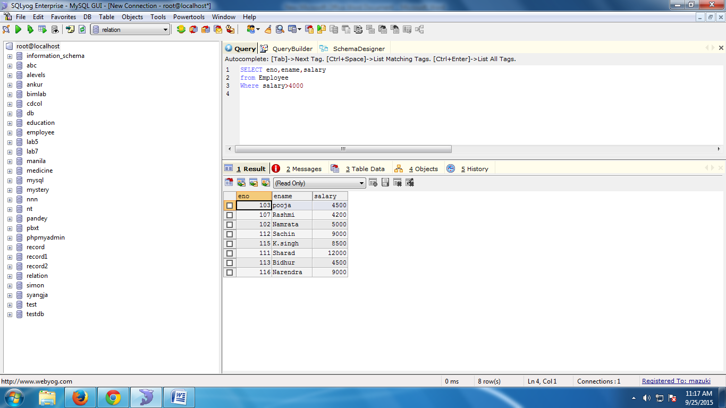

Find the eno, ename salary of the employee whose salary is greater than 5000 and job status is professor

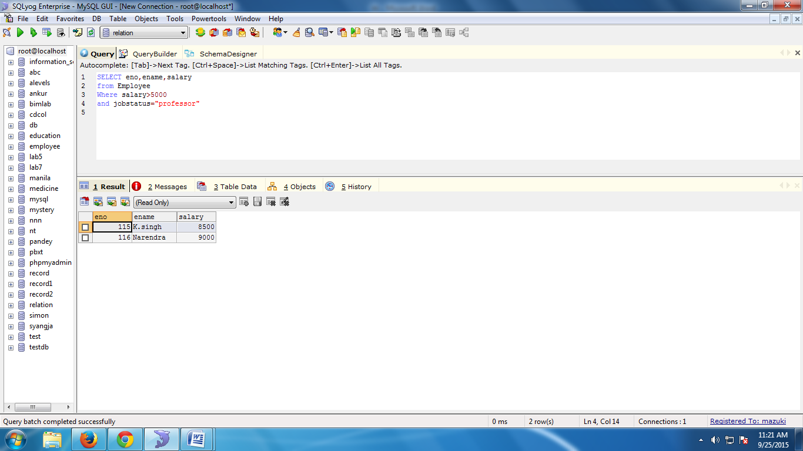

Find the eno,ename,age and salary from the employes where age is between 24 and28

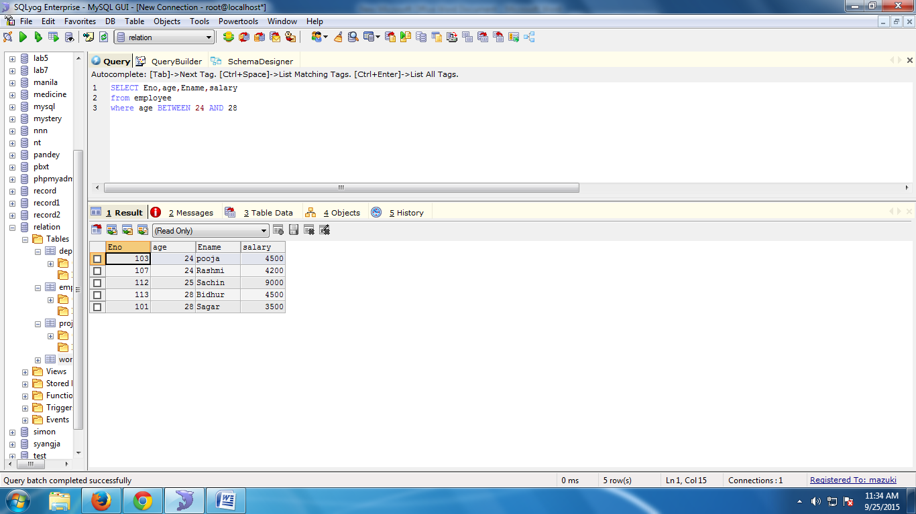

Fin the eno ename whose starting letter”Sa”

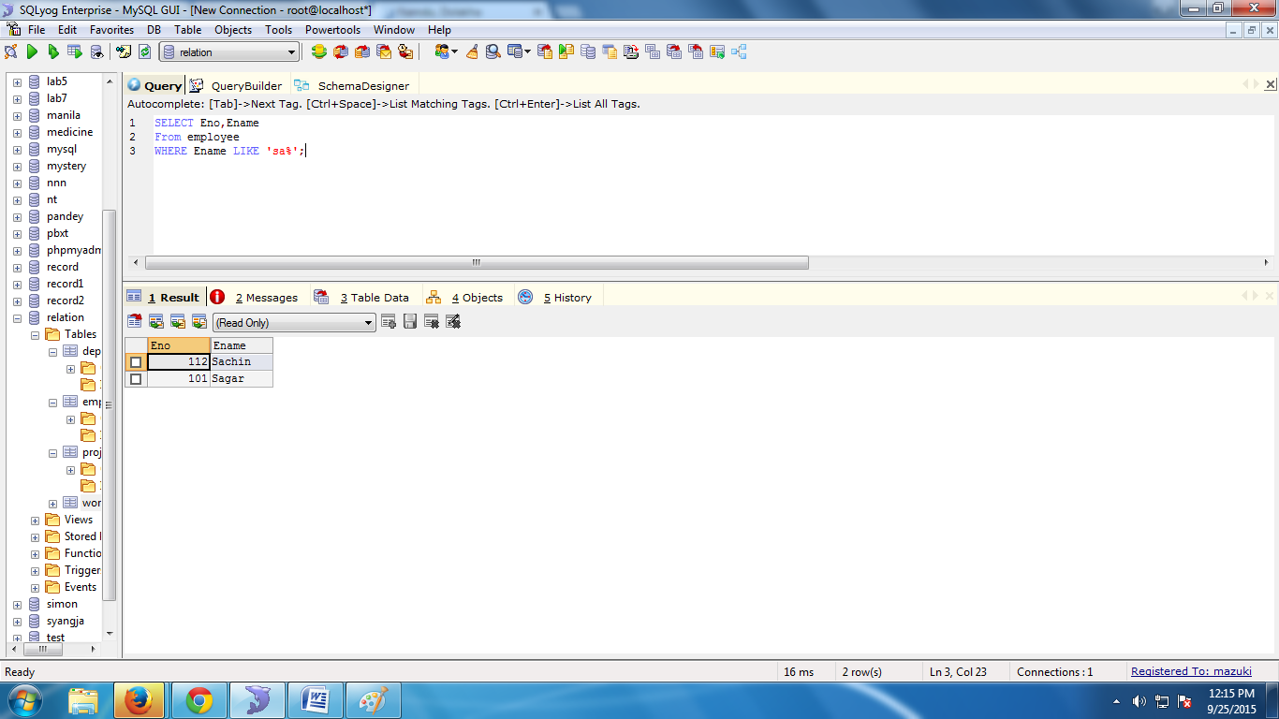

1. List all employee names with their project names
2. List name of all employee and their salary who are working in project mars or venus.
3. List name of all employee and their salary who are working in project earth and venus.
4. List name and address of all employee who works in department which is located in Pokhara.